**PROJECT-3**

**STEP 1:**Create twolinux instances,Use the first free linux AMI.

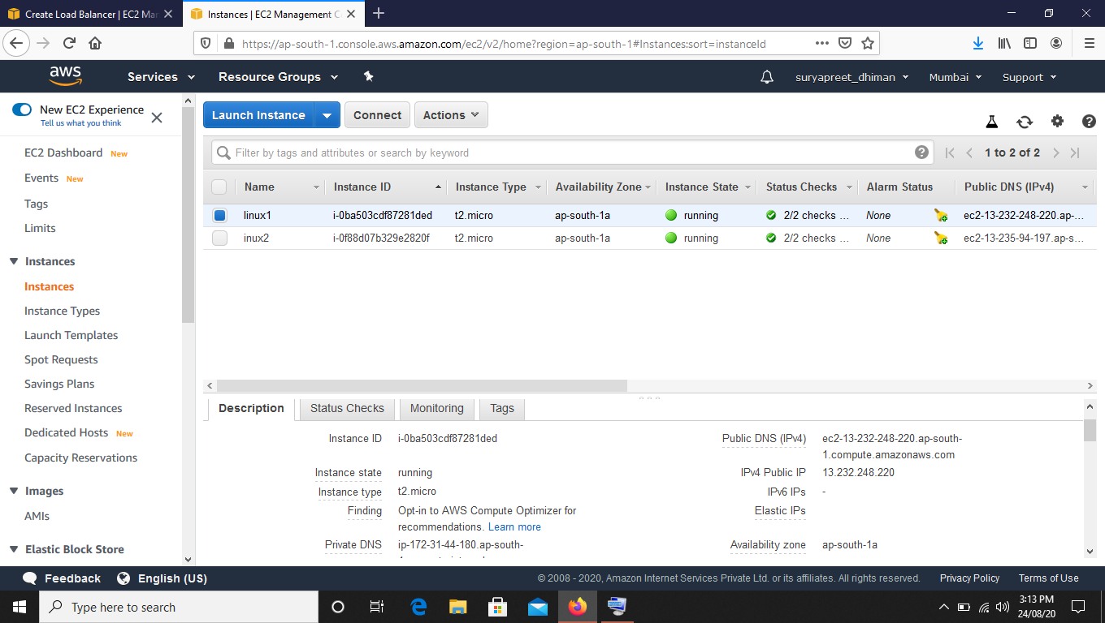

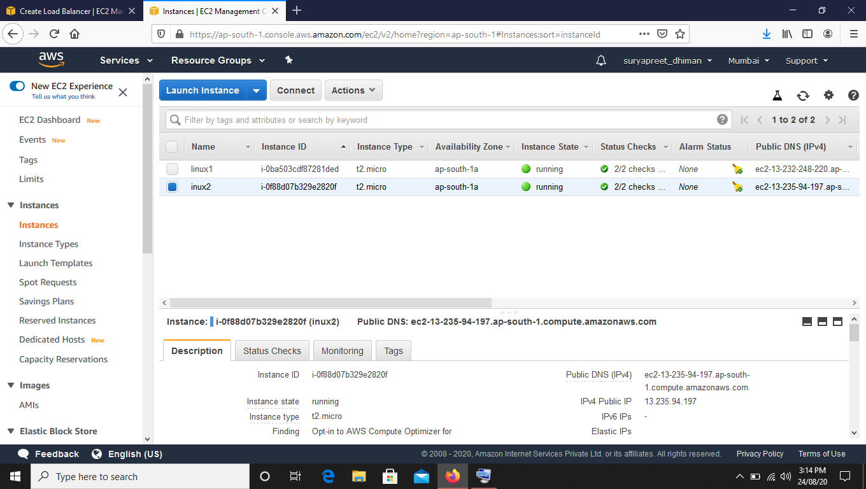

**STEP2 :**Launch both instances using Mobaxterm.

**STEP 3**: Host html login webpage on both servers.

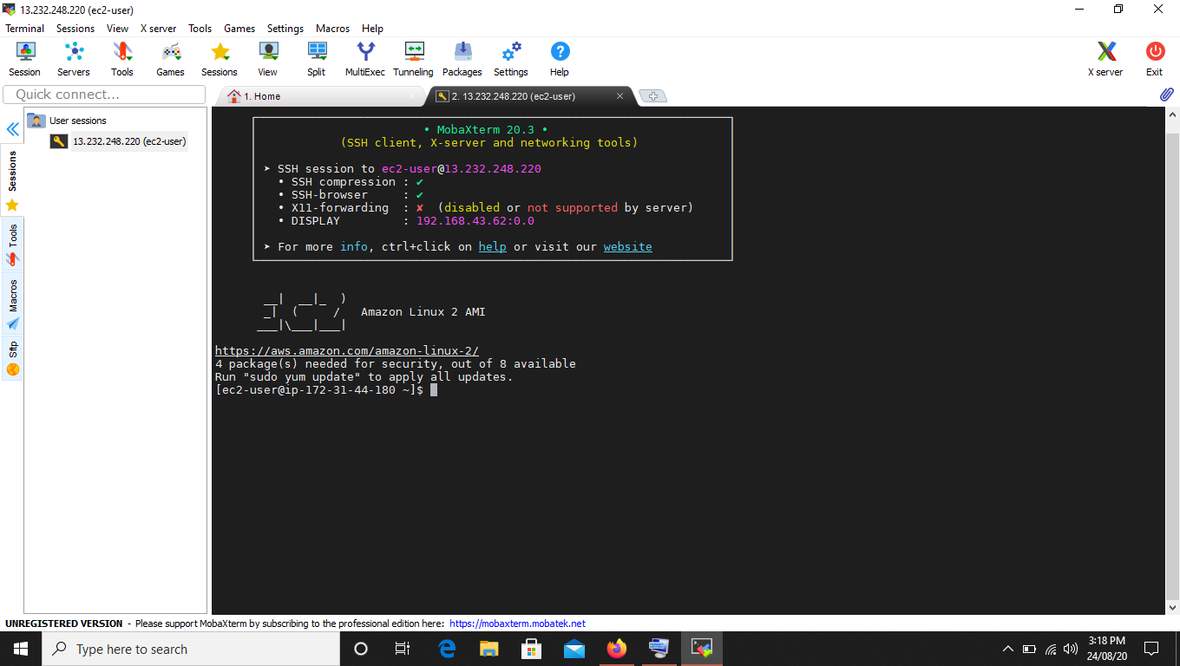

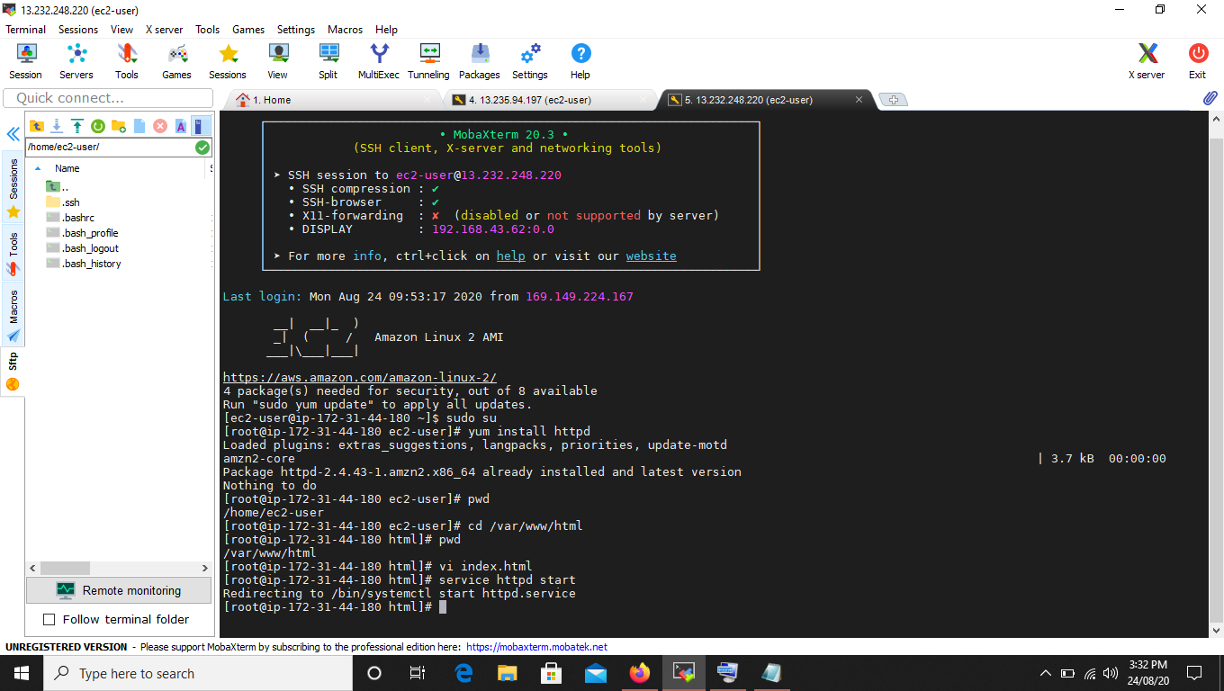

**STEP4 :** Check if the application is deployed on both servers by pasting the public IP in the browser.

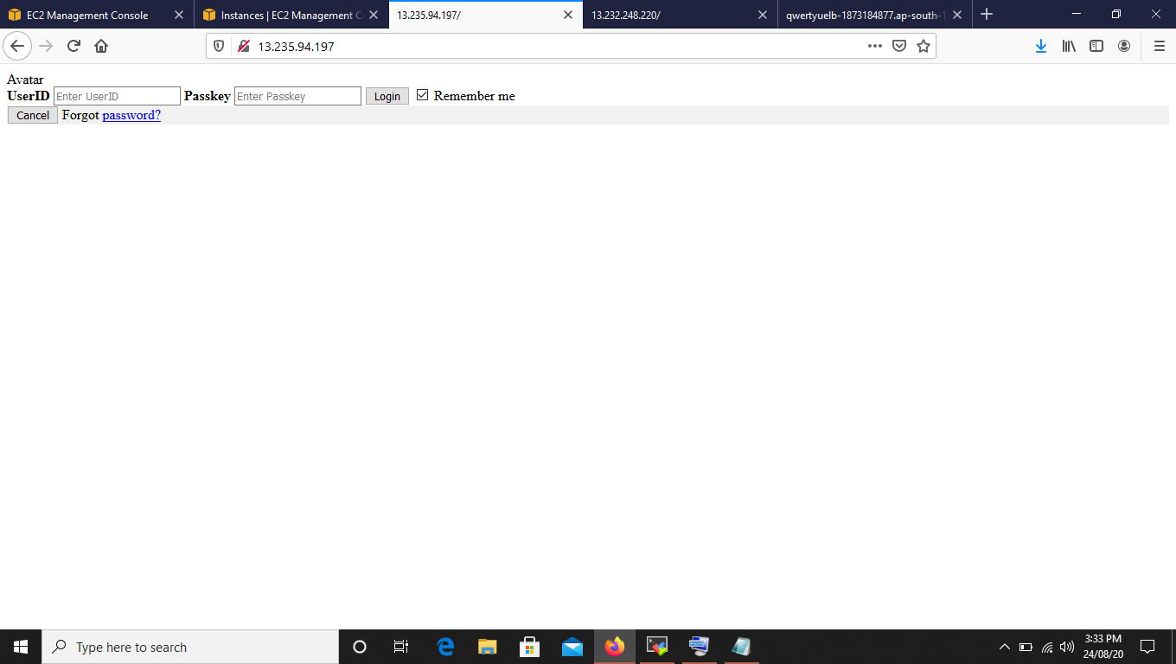

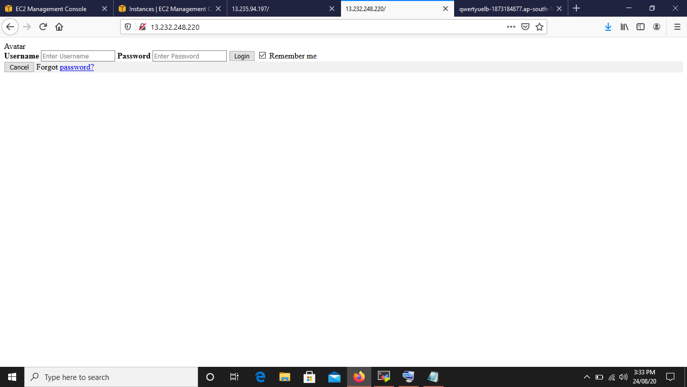

**STEP 5:** Create an application Load Balancer with the above two instances as target.

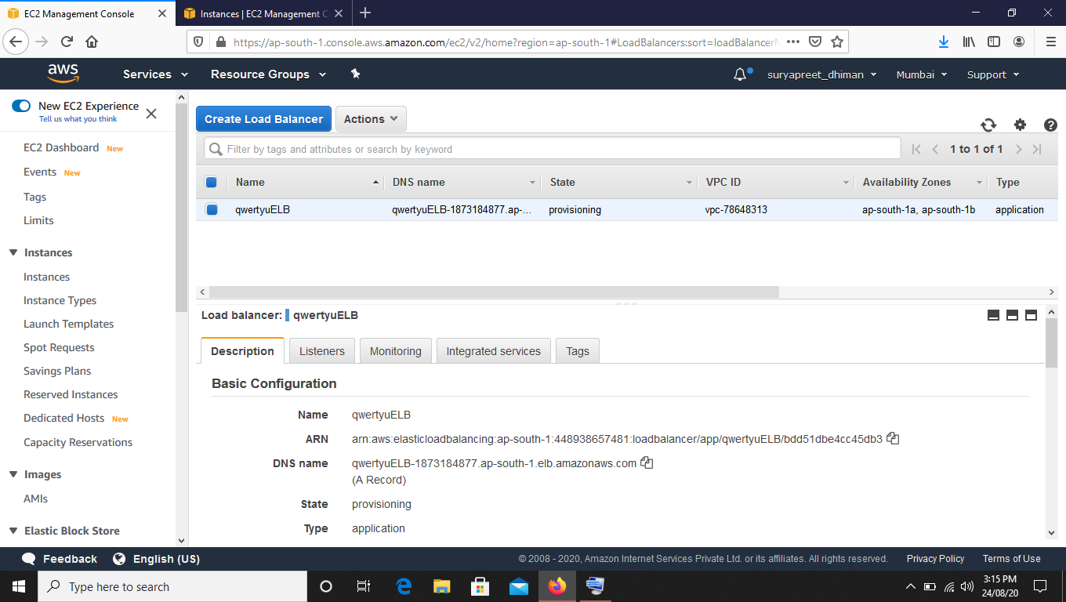

**STEP 6**: Check the functioning o ELB.

